Oracle is a ORDBMS product / DB software / backend tool from “oracle corporation” introduced .

Larry Ellison and team started consultancy software development in 1977 , which became RSI in 1983 and later to Oracle Corporation

In 1979 RSI introduced Oracle V2 ( version 2 ) as the first commercially available SQL – based RDBMS

It is one of the most popular ORDBMS in IT market for storing , organizing and retrieving data.

It can be deployed in almost all leading operating systems such as Linux , windows , Mac , Solaris IBM Aix , etc..

Editions of Oracle :

* **Enterprise Edition:**  It offers all features, including superior performance and security.
* **Standard Edition:** It provides the base functionality for users that do not require Enterprise Edition's all features .
* **Express Edition (XE):** It is the lightweight, free and limited Windows, and Linux edition.
* **Oracle Lite:** It is designed for mobile devices.
* **Personal Edition:** It's comparable to the Enterprise Edition but without the Oracle Real Application Clusters feature.

Oracle Client Server Architecture :

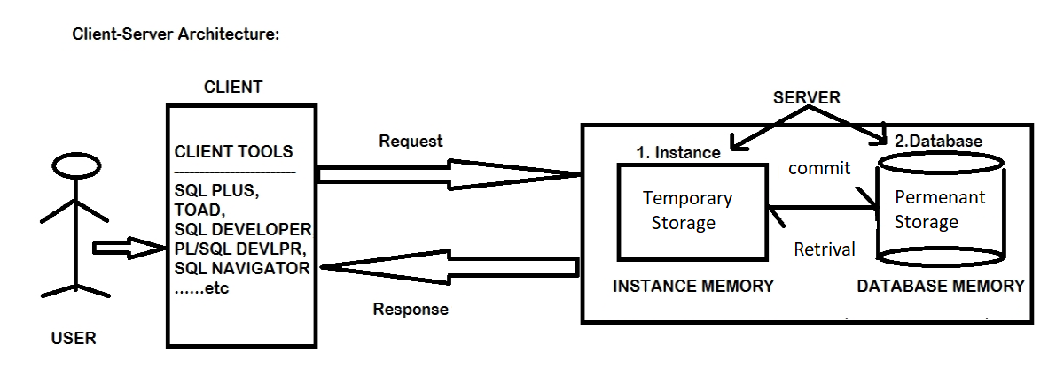

Here user uses some client tools Eg: SQL plus , Toad , SQL Developer , PL/Sql Developer , Sql , Navigator to connect , request any data and get the response from the server. And to communicate with the database a language is needed i.e sql ( structured query language )

1. In the first step connect to the server with the login credentials .
2. Write any sample query and execute that . it will be stored temporarily in the instance memory . now if user disconnects , then the data will be lost. Then the user has to login again and do the operations again.
3. To avoid data loss , the data should be moved from instance to database using the command “commit” . once the data is moved to database , it is stored permenantly unless it is removed / deleted by the user.
4. The stored data can be retrieved whenever the user needed.

Is SQL Plus and SQL same ?

SQL Plus is a client tool introduced by Oracle, that is used to connect to the sever ( database ) ,request any data and get response.

While SQL is a language used to communicate with the database .

So for connecting with Oracle database SQL Plus is used and to communicate with that database SQL is used.

Connecting with the database

1. Open SQL plus and give the username and password . by default the password is not visible to user .
2. If you want to see the password while connecting use “ conn” command and execute/ press enter

* Syntax : username/password

During the login if “TNS protocol adapter error” arise , to solve this

* Go to services
* Navigate to oracleserviceORCL
* Select the startup and make it “automatic”
* Click on start and ok.

ORA-28000 : this account is locked.

If this error arises login as system dba administrator

To login as system dba administrator use command

* \sys as dba in the user name and give the password .
* To lock / unlock a user in the oracle database server

Syntax : ALTER USER <username> ACCOUNT LOCK/UNLOCK;